Availability Management

Why:
Gartner research shows that people and/or process failures directly cause an average of 80 percent of mission-critical application service downtime. The other 20 percent is caused by technology failure, environmental failure or a disaster. The complexity of today's IT infrastructure and applications makes “high-availability” systems management difficult. Applications requiring high levels of availability must be managed with operational disciplines – including network monitoring, systems management activities, etc. - to avoid unnecessary and potentially devastating outages. Availability Management is a proactive operations management discipline, which has direct and high returns from an application availability perspective. This discipline involves the use of automated tools to avoid problems (e.g., automatically increasing available file space when a threshold is reached) and job scheduling to reduce operator error and improve the availability of batch applications and data.

GOAL:
To optimise the capability of the IT Infrastructure, services and supporting organisation to deliver a Cost effective and sustained level of Availability that enables the business to satisfy its business objectives.

ACTIVITIES:
- Determining availability requirements
  - Input from Service Level Management
- Determining vital business functions (VBF’s)
  - Input for IT Service Continuity Management
- Business impact analysis
  - Risk Analysis Management (input for IT Service Continuity Management)
- Defining availability, reliability and maintainability targets
  - Input for Service Level Agreements (SLAs) and other contracts
- Monitoring & trend analysis
  - MTBF (Mean Time between Failures)
  - MTBSI (Mean Time between System Incidents)
  - MTTR (Mean Time to Repair)
  - Planned downtime, unscheduled downtime, Extended (excess) Downtime
  - Frequent (scheduled) backups
- Root cause analysis of low availability
  - Relationship with the Problem Management process
- Producing & maintaining an Availability Plan
- Reporting

Availability % = (Actual availability / agreed availability) * 100%

Terminology:
Availability: Key indicator of the service provided. It should be defined in the Service Level Agreement
Reliability: Reliability of the service is made up out of the reliability of Service Components and the resilience of the IT infrastructure.
Serviceability: Contractual arrangements with 3rd parties in regards to maintenance
Maintainability: The ability of the IT group to maintain the IT infrastructure in operational state and available according to the agreed service levels
Security: Confidentiality, Integrity and Availability (CIA) of DATA
Vital Business Function: The business critical element of the business process that is supported by the IT service.
Resilience: The ability of individual components to absorb or be flexible in times of stress.

Other Process RelatioNships
The connection between Incident Management (detection), Problem Management (diagnosis), Change Management (repair time) and Availability Management is shown in the following diagram:

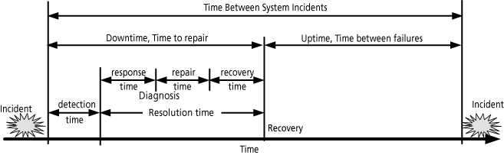
The following metrics are commonly used in Availability Management:
- Mean Time to Repair - MTTR: average time between the occurrence of a fault and service recovery (or the downtime).
- Mean Time Between Failures - MTBF: mean time between the recovery from one incident and the occurrence of the next incident.
- Mean Time Between System Incidents - MTBSI: mean time between the occurrence of two consecutive incidents. The MTBSI = MTTR + MTBF.
The ratio of MTBF to MTBSI shows if there are many minor faults or just a few major faults.
Availability reports may include the following metrics:
- Rate of availability (or unavailability) in terms of MTTR, MTBF and MTBSI
- Overall uptime and downtime, Number of faults
- Additional information about faults which actually or potentially result in a higher than agreed unavailability.

RESULTS:
- Agreed targets of Availability (including Availability criteria for new services)
- Availability reports (Knowledge of End-to-end SERVICE availability

- )
- Availability Plan

COST:
- Personnel – staff (Set-up and ongoing)
- Accommodation – Physical location (Set-up and ongoing), also for documentation
- Software – Tools (Set-up and ongoing), monitoring and reporting tools
- Hardware – Infrastructure (Set-up and ongoing), perhaps you need a dedicated database
- Education – Training (Set-up and ongoing)
- Procedures – external consultants etc (Set-up)

BENEFITS:
- A single point of accountability
- IT services are designed to meet the IT requirements designed by the business
- Improvement of business continuity

- Cost justification of investments
- The levels required are agreed to support SLM
- The mindset is changed from reactive to proactive
- Improved image of IT organisation

